**Three tier architecture**

**A Three tier Architecture is a well-structured way to build scalable, secure, and manageable applications by dividing them into three layers.**

**Web-Tier (Frontend): The Web tier is the user interface and communication layer of the application, where the end user interacts with the application. Its main purpose is to display information to and collect information from the user. This top-level tier can run on a web browser, as desktop application, or a graphical user interface (GUI). Web presentation tiers are developed by using HTML, CSS, and JavaScript. Desktop applications can be written in various languages depending on the platform.**

**Application-Tier (Business Logic): The application tier, also known as the logic tier or middle tier, is the heart of the application. The application tier is typically developed by using Python, Java, Perl, PHP or Ruby, and communicates with the data tier by using API calls.**

**Data-Tier (Data Storage): The data tier, sometimes called database tier, data access tier or back-end, is where the information that is processed by the application is stored and managed. This can be a relational database management system as PostgresSQL, MySQL,MariaDB.**

Steps

* Create vpc , public subnet and private subnet, Nat gateway , route table and associate subnet with route table
* SSH into private instance via public instance (bastion host instance)
* Install apache2 into private instance and delete or edit index.html file with your application
* Create Target group , and Register only private instance
* Create Load balancer with above TG
* Now access application of private instance by using DNS of load balancer
* Now create RDS database with same SECURITY GROUP as private instance
* SSH into private instance install mysql-server and enter into database which you created
* Perform schema operation
* Now create image of private instance
* Create launch template with using same image of private instance
* Create ASG
* See instance has created according to ASG
* Now go target group and register new instance which are created by ASG
* AND DERIGESTER private instance from target group
* Now copy the dns of load balancer and paste it in browser
* Success

Creating vpc

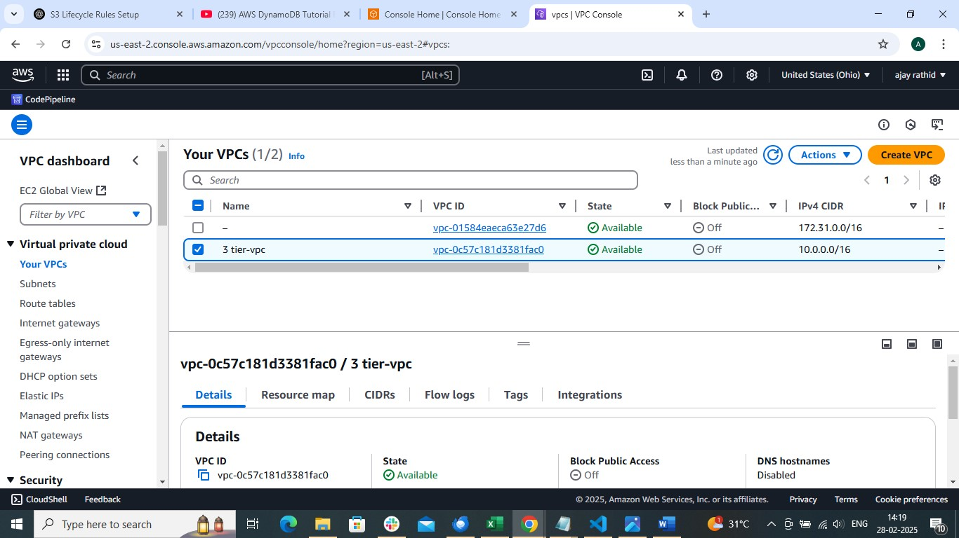

Create public and private subnet

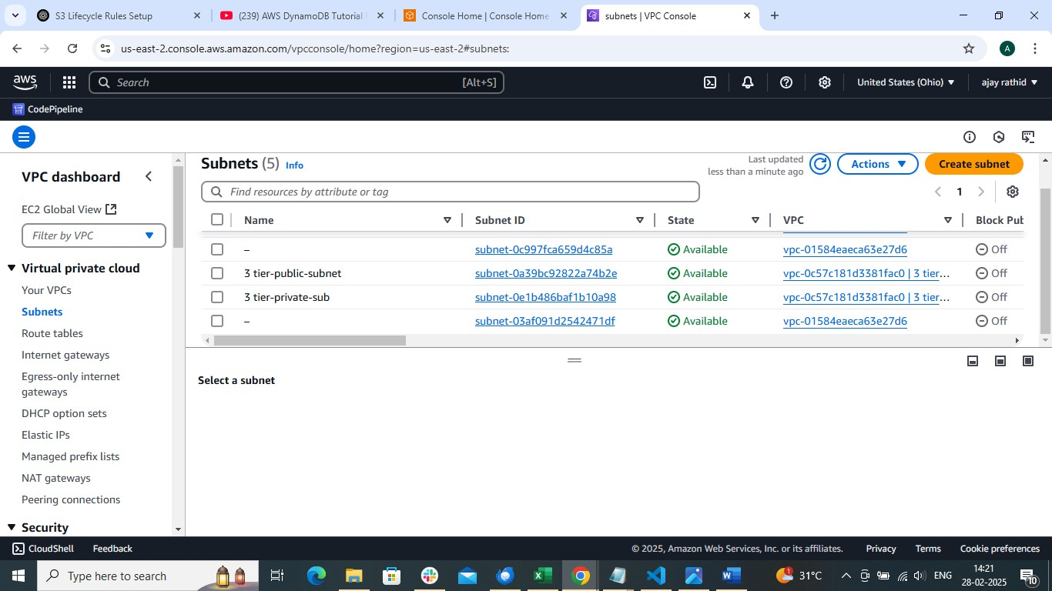

Create Internet gateway

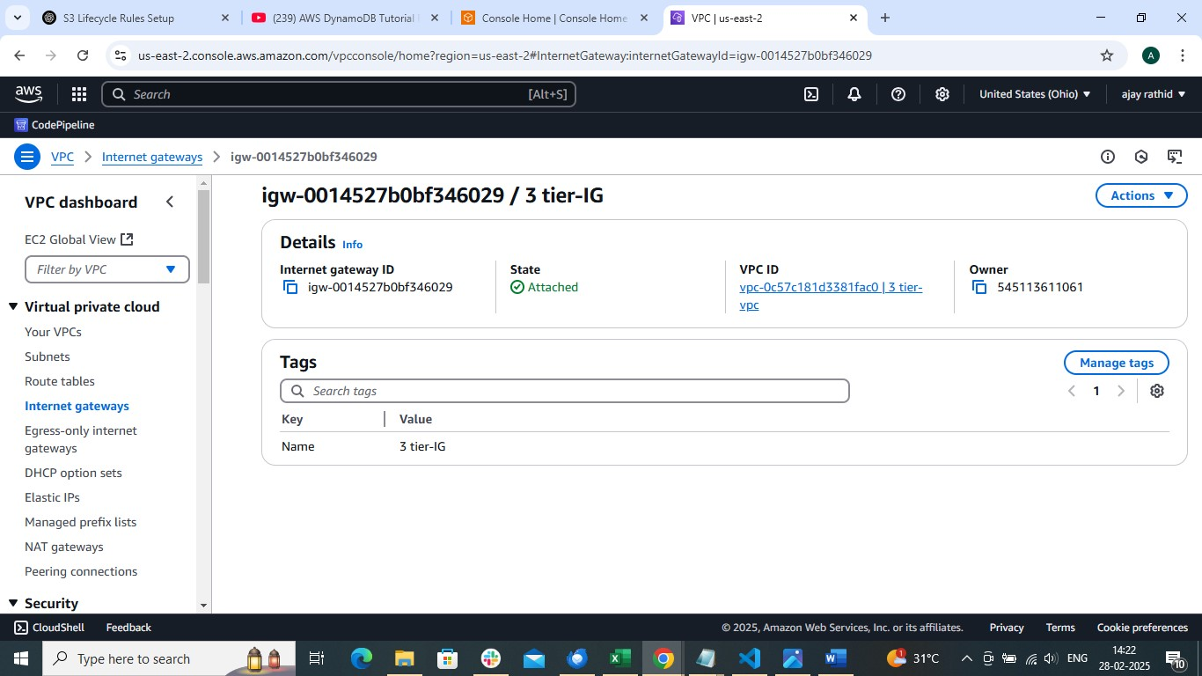

Create public and private Route tables and associate with public and private subnet along with their Routers (internet and Nat gateway respectively)

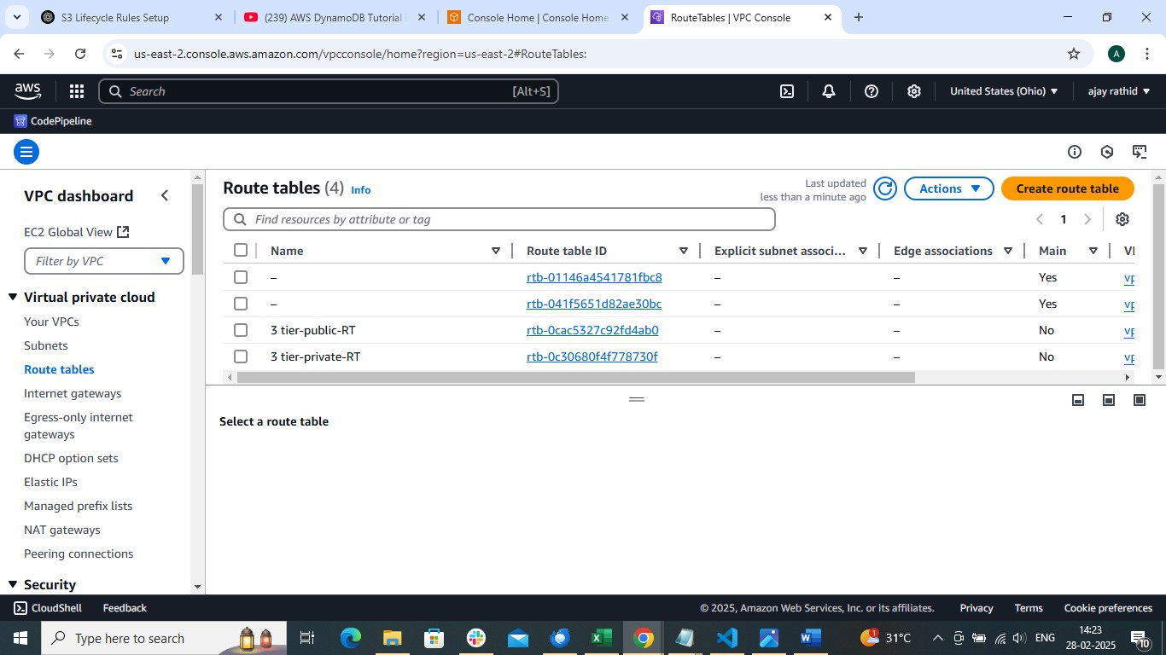

Create Nat gateway

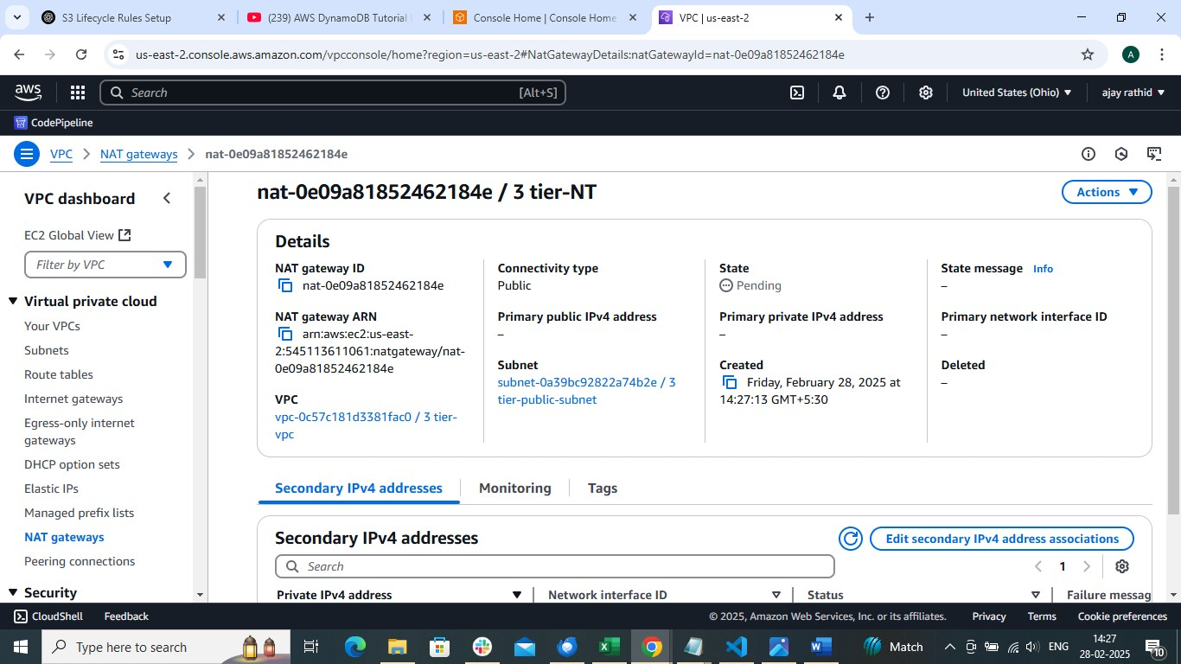

Launch public instance

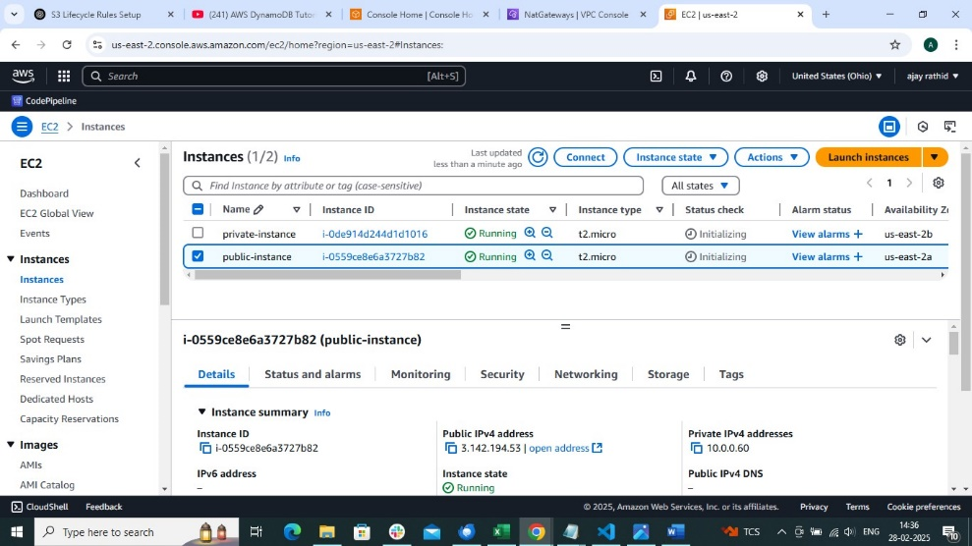

And enter into private instance

* Create key.pem
* chmod 400 key.pem
* ssh -i key.pem ubuntu@privateIp:/home/ubuntu

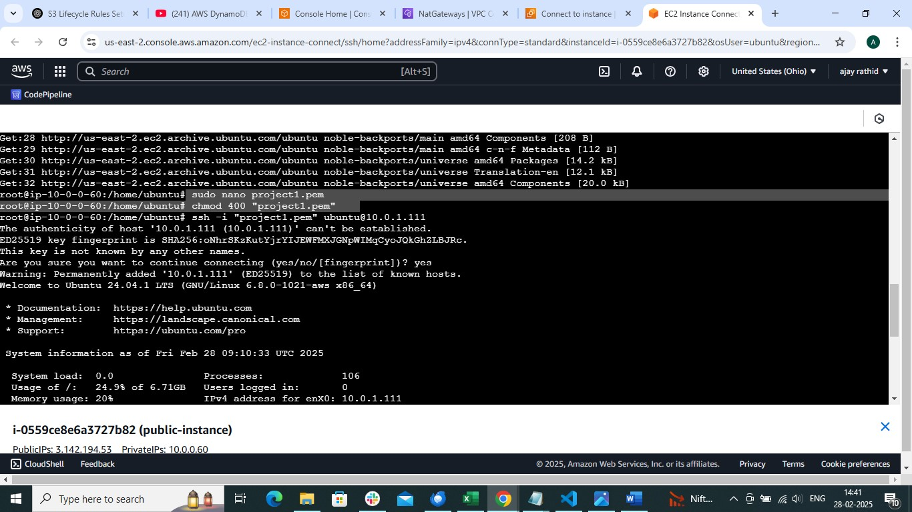

Install apache2

* apt install apache2

Delete index.html and replace it index.php

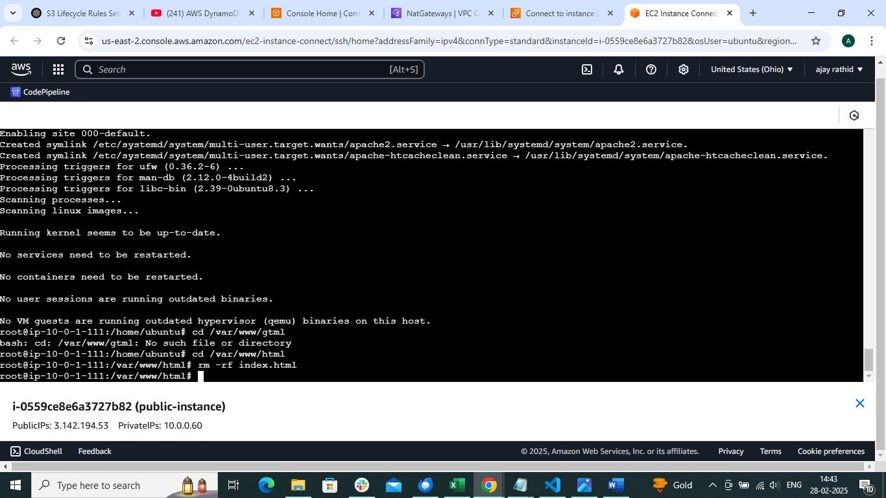

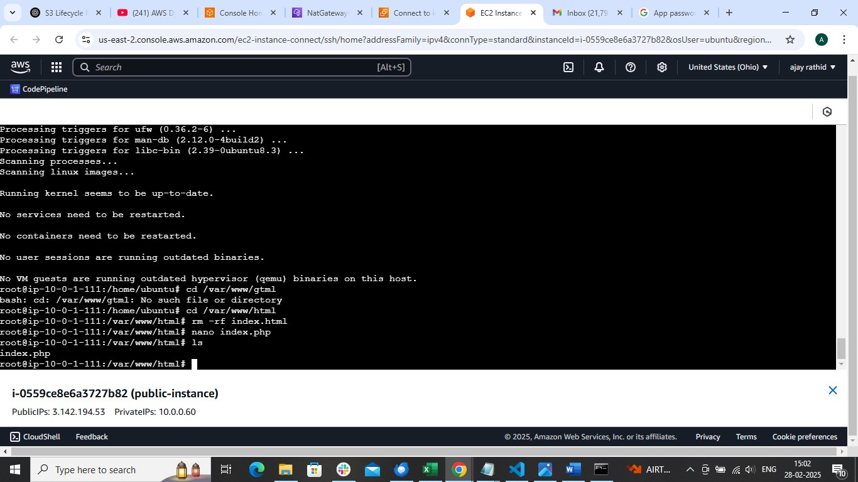

Now create target group and load balancer

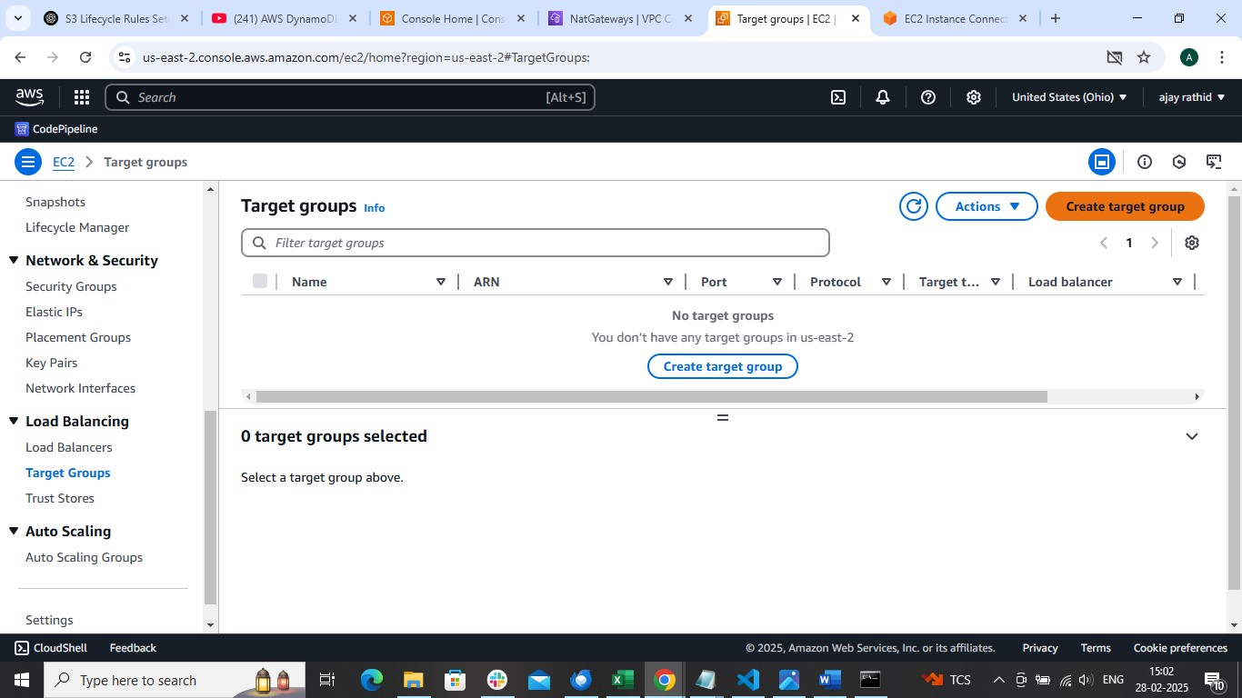

Add only private instance

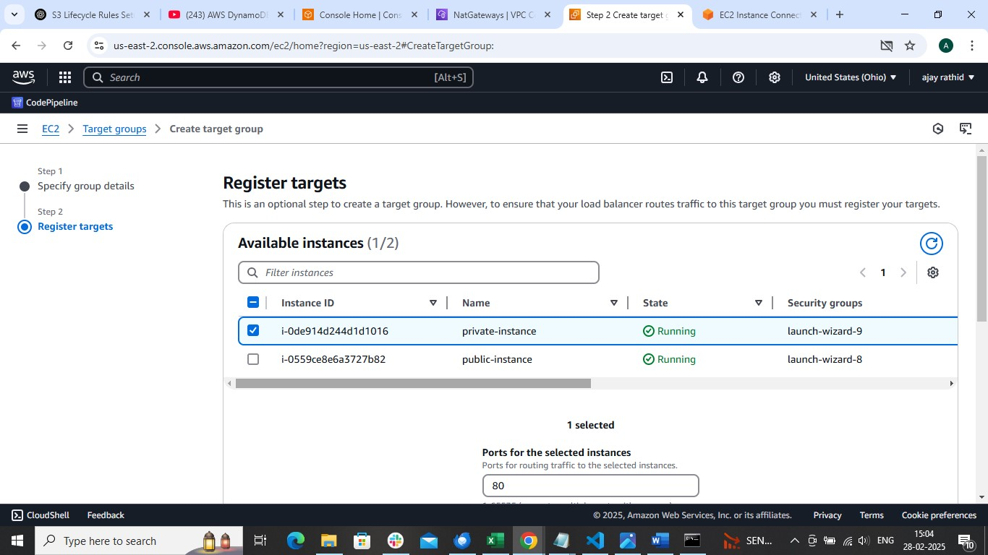

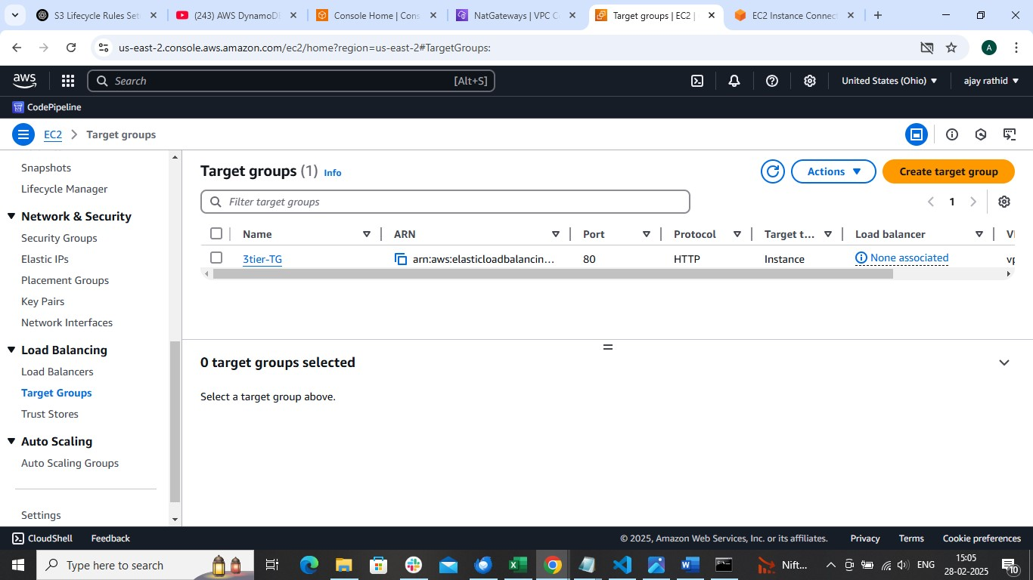

Create load balancer

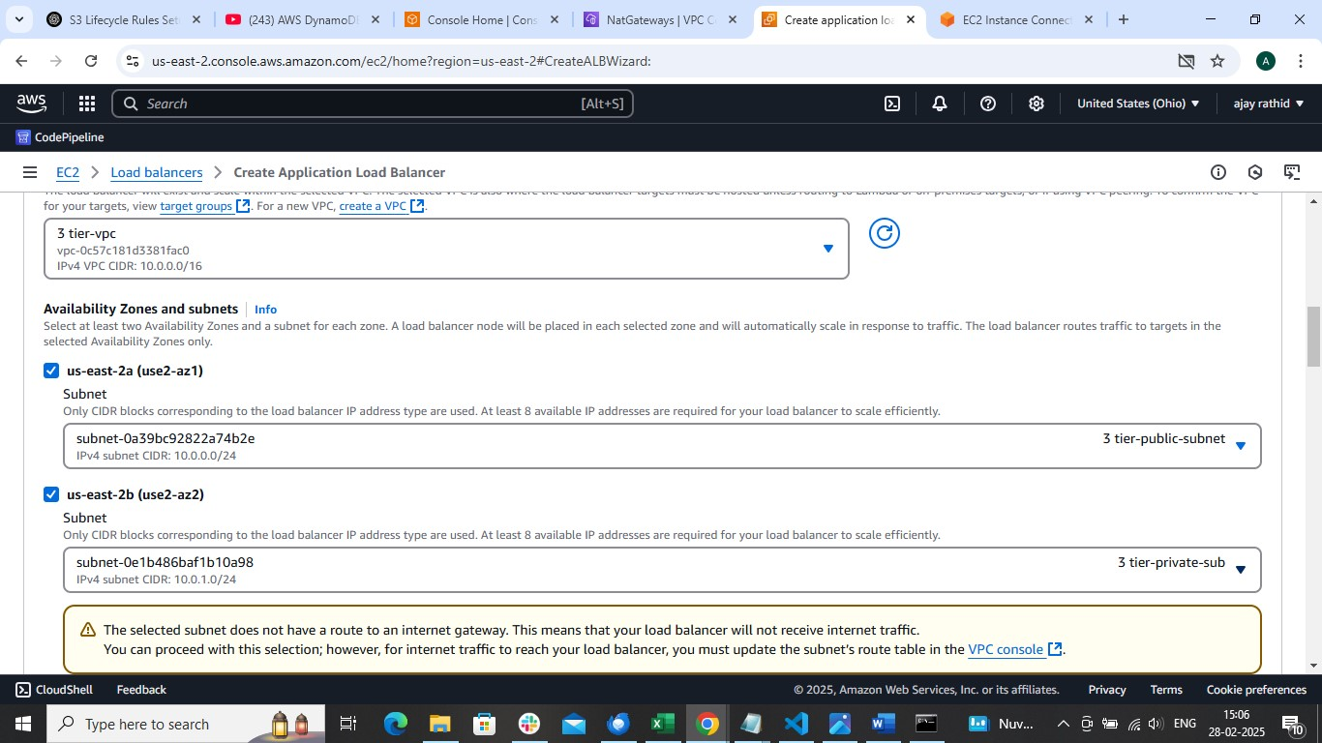

Add target group

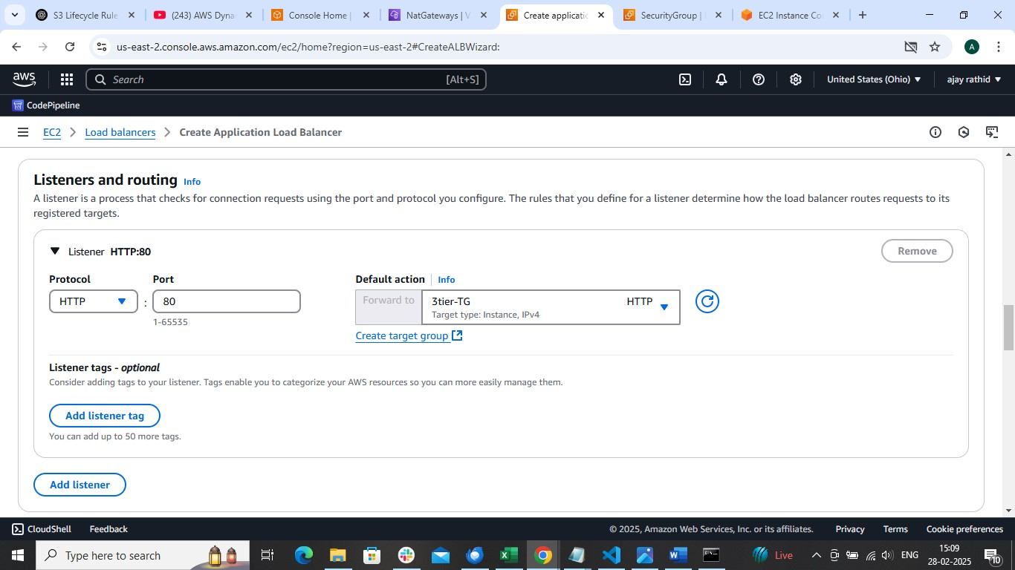

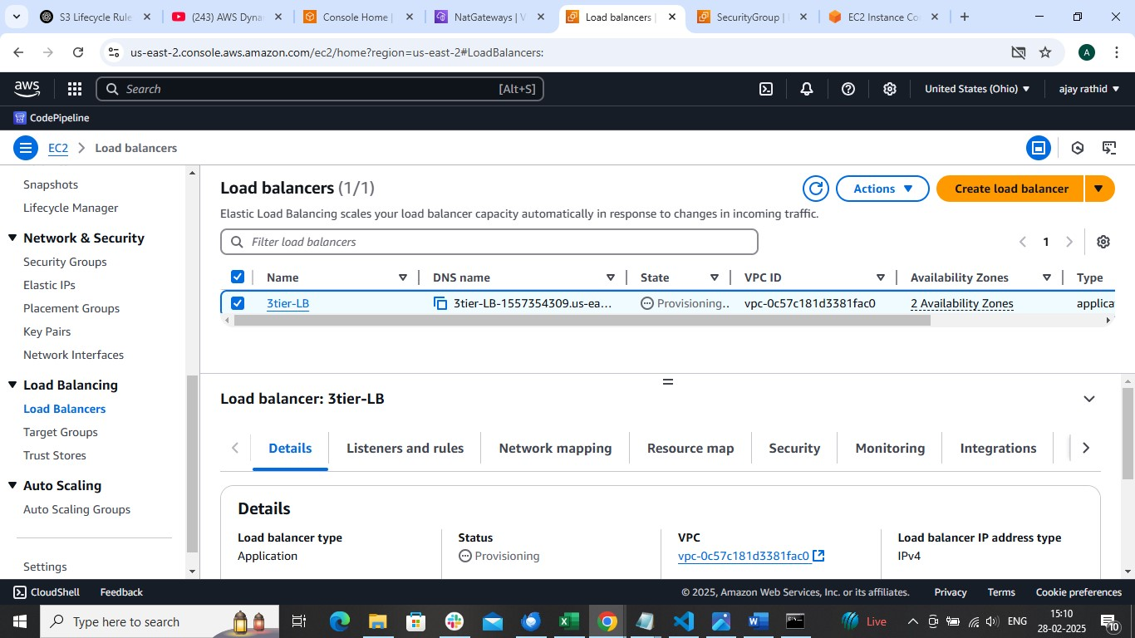

Access the application using dns of Load balancer

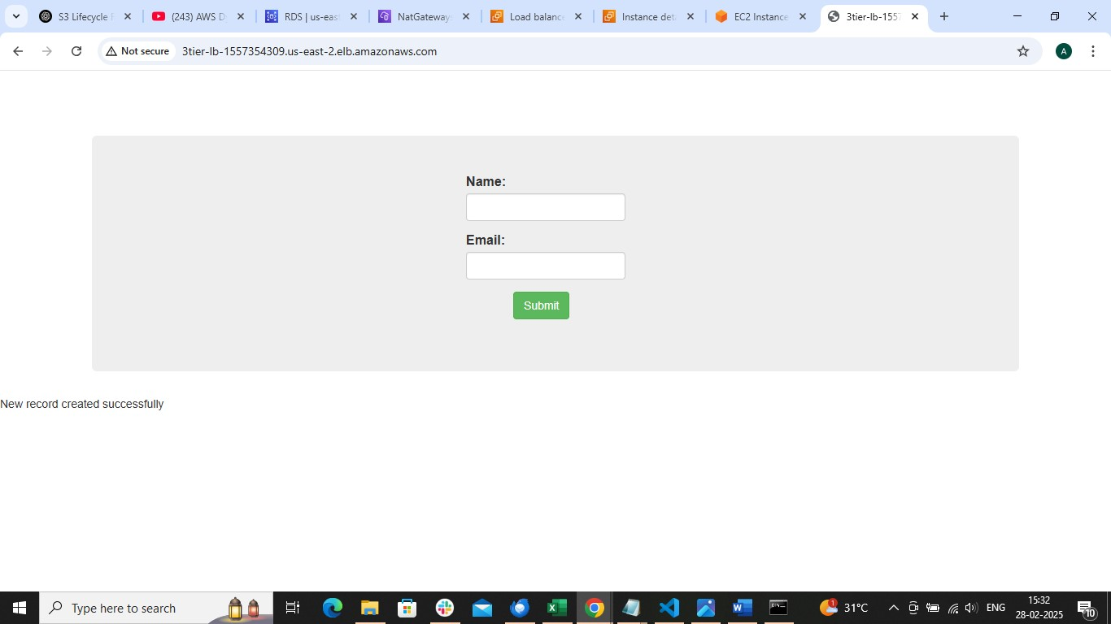

Now create database with same security group of private instane

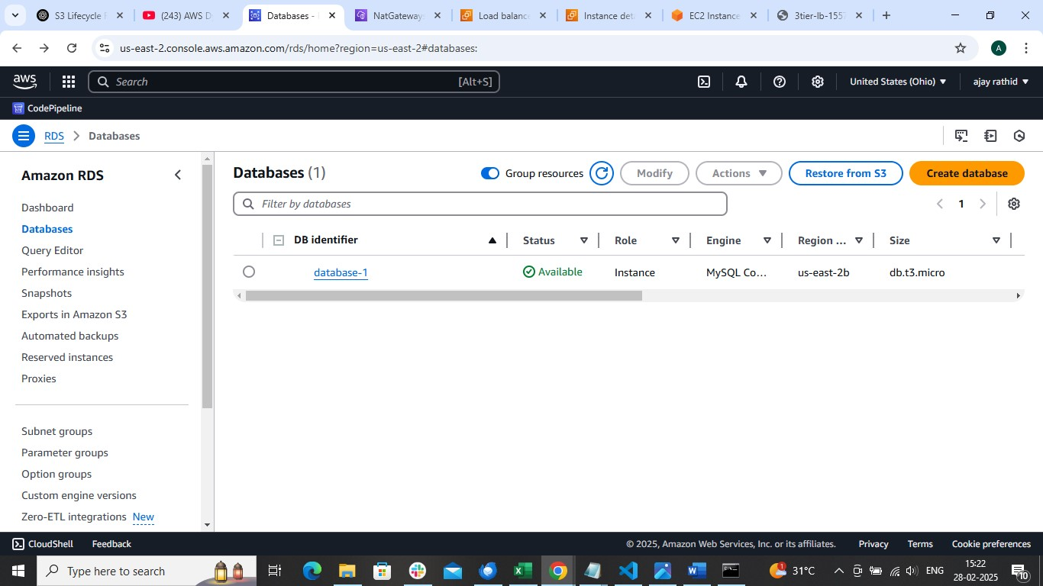

Now enter into private instance and install mysql

* sudo apt install mysql-server -y
* sudo systemctl start mysql.service
* add-apt-repository -y ppa:ondrej/php
* apt-get install mysql-client -y
* sudo apt install php5.6 php5.6-mysqli -y

enter into database

mysql -h <end point of rds> -u <username> -p

enter password

<mysql> show databases;

<mysql> use <database-name>;

<mysql> create table data (firstname VARCHAR (20), email VARCHAR (20));

Now open browser with dns of load balancer



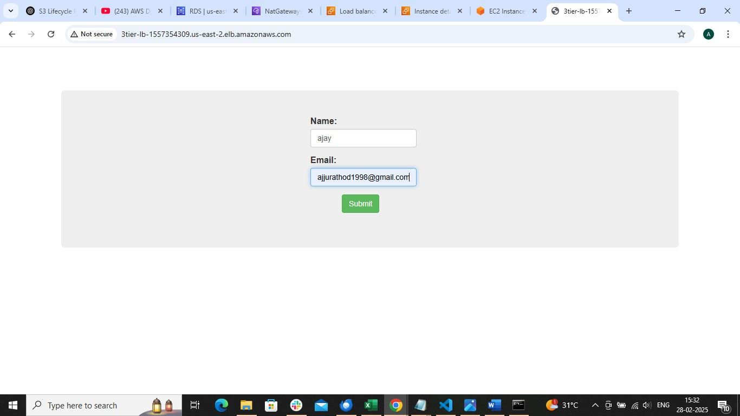

Run command

SELECT * FROM DATA

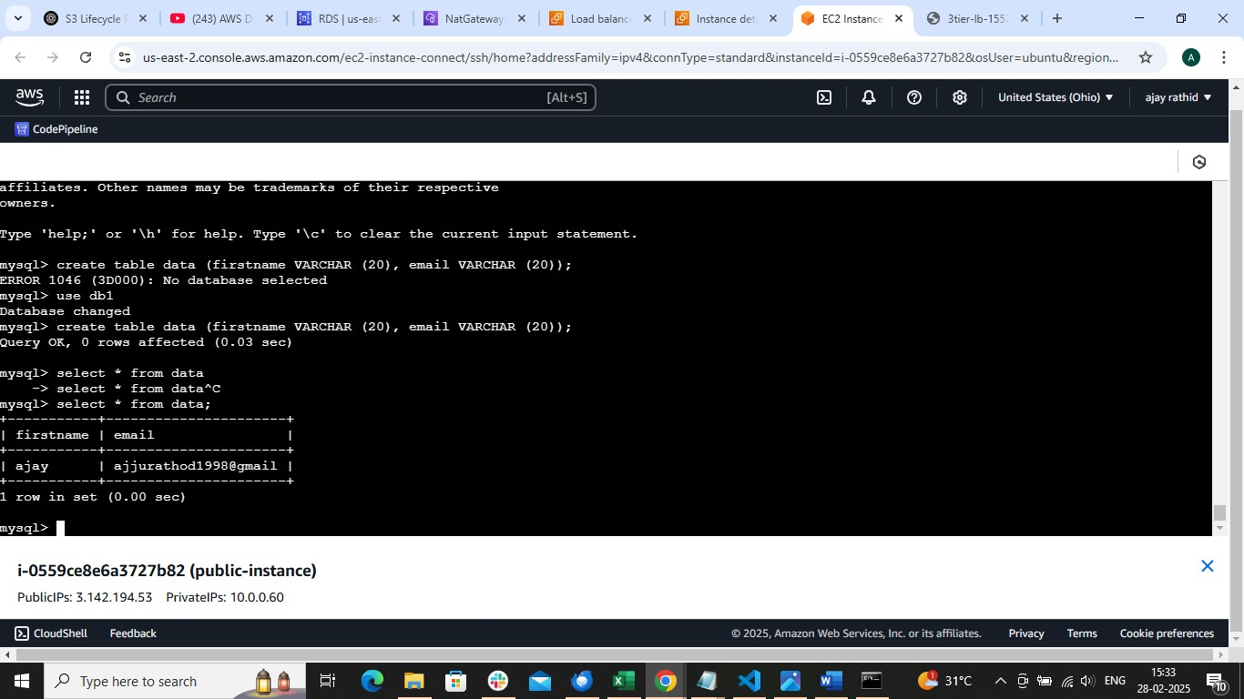

Now to attach ASG

Create a image of private instance

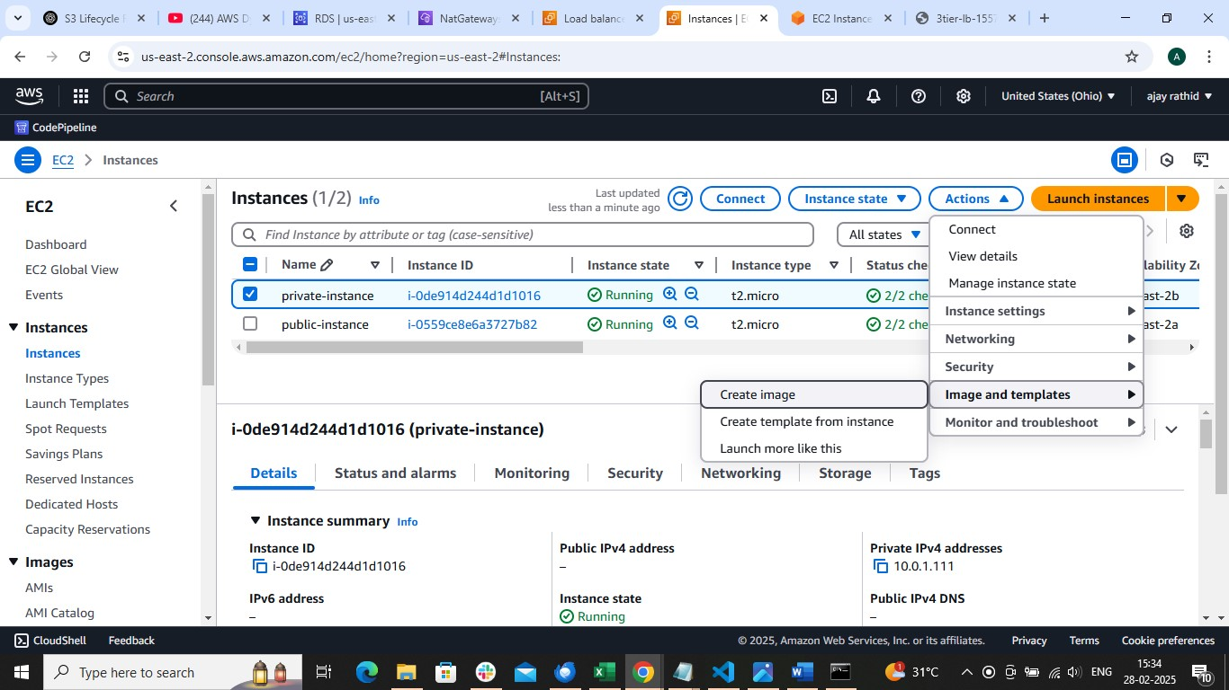

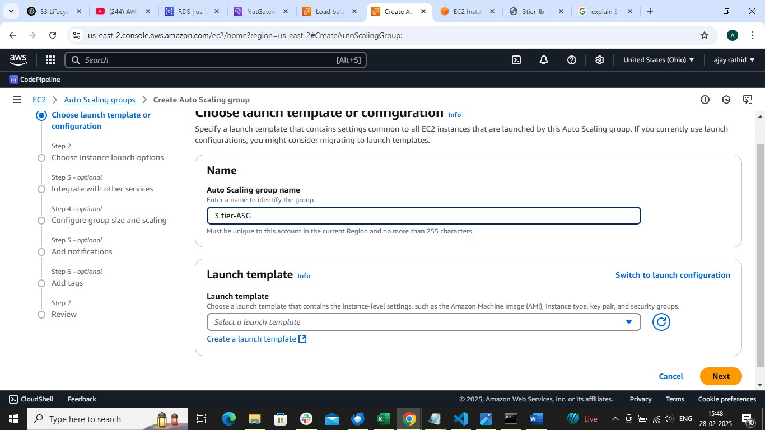

Use same image of private instance and choose created vpc and subnet etc

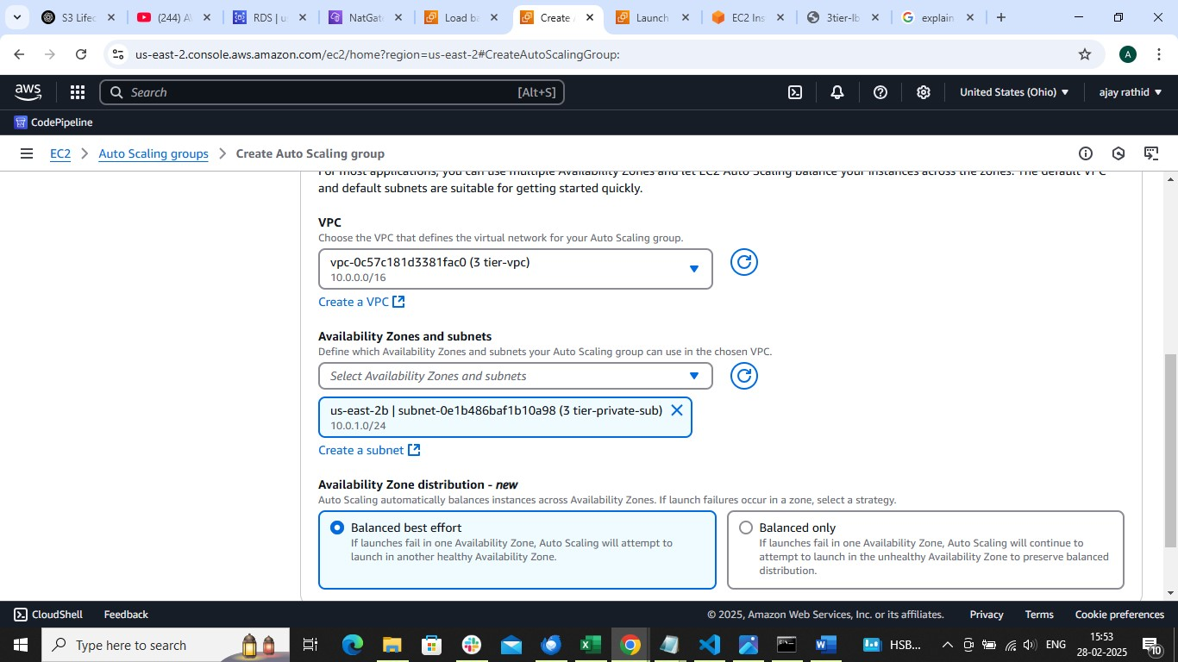



Attach existing load balancer

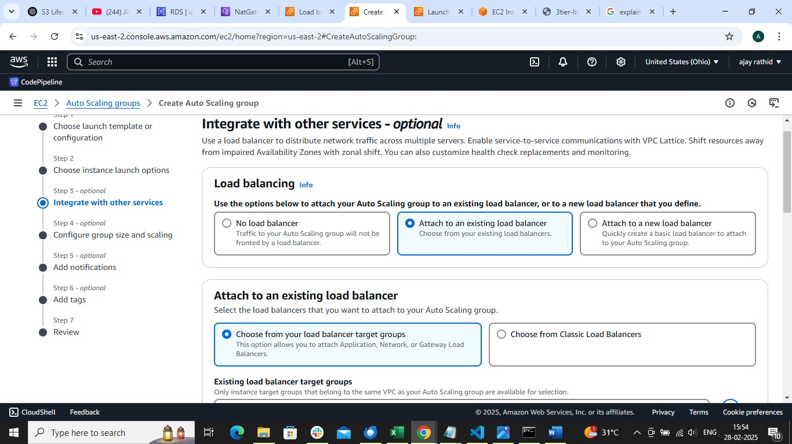

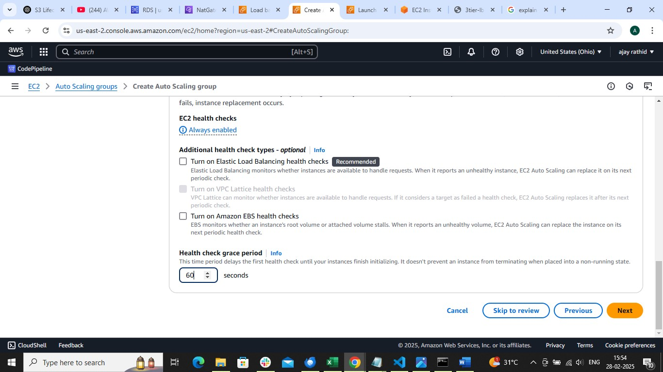

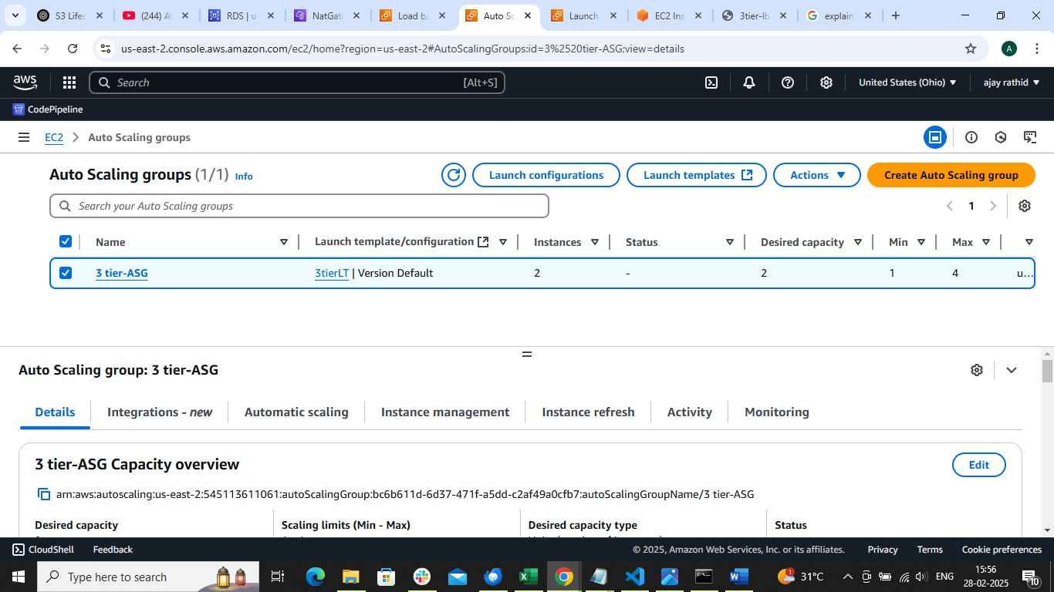

Now go to the target group and deregister existing private instance

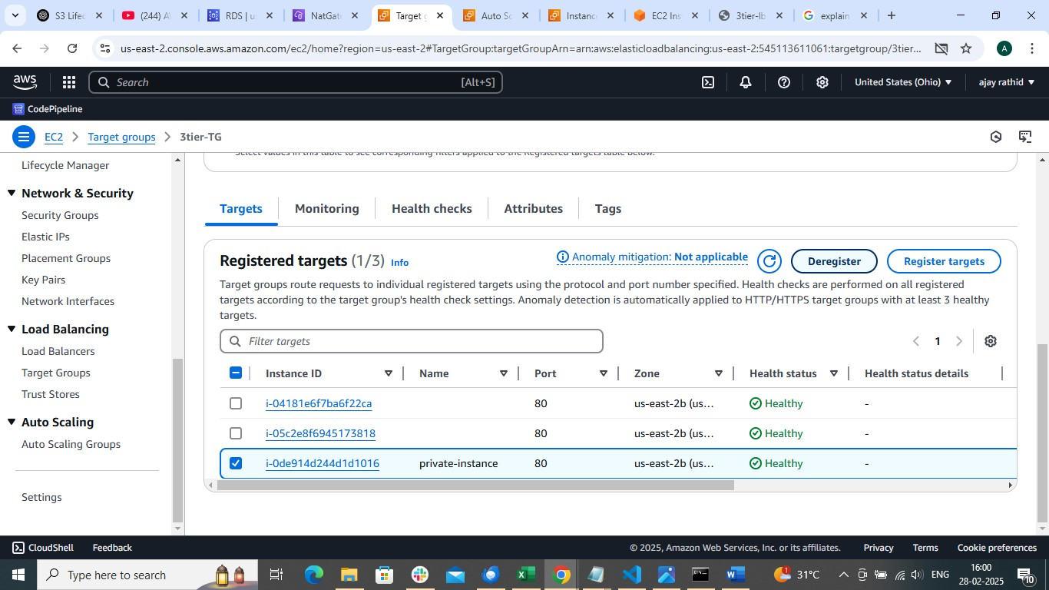

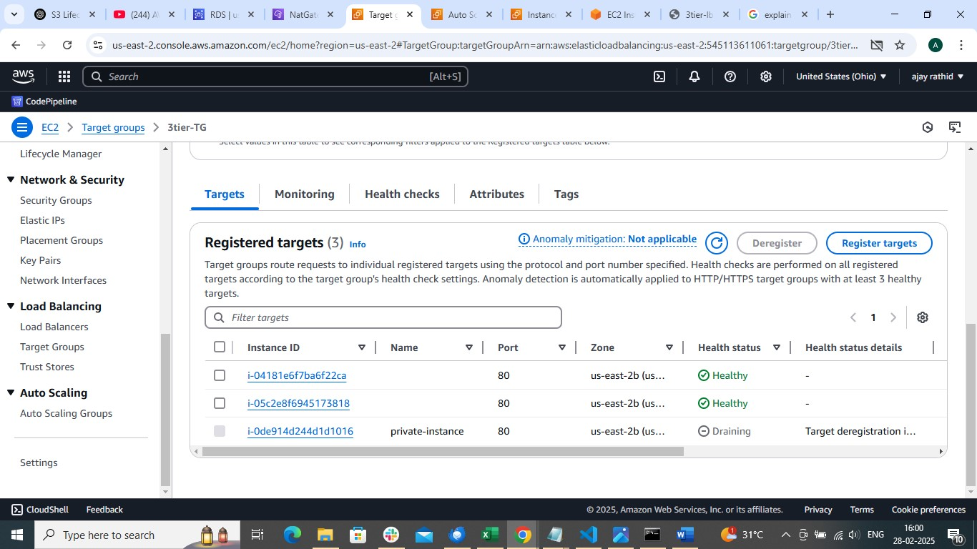

Go to the load balancer and copy the dns name and paste it on browser

